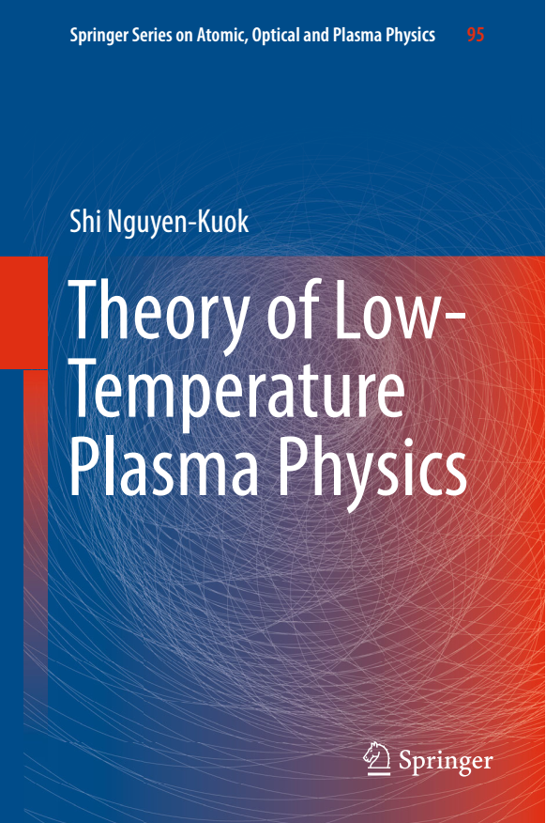© 2017

Theory of Low-Temperature Plasma Physics
Authors: Nguyen-Kuok, Shi

http://www.springer.com/gp/book/9783319437194
- Physics Atomic, Molecular, Optical & Plasma Physics
- Springer Series on Atomic, Optical, and Plasma Physics

- Offers a comprehensive overview of the theoretical description and mathematical modeling of low-temperature plasmas
- Presents results of the simulation and calculation of plasma parameters in induction and arc plasma torches
- Reviews the characteristics of different types of plasma torches and their potential for application in plasma chemistry, plasma welding and plasma cutting
- About this book
This book offers the reader an overview of the basic approaches to the theoretical description of low-temperature plasmas, covering numerical methods, mathematical models and modeling techniques. The main methods of calculating the cross sections of plasma particle interaction and the solution of the kinetic Boltzmann equation for determining the transport coefficients of the plasma are also presented. The results of calculations of thermodynamic properties, transport coefficients, the equilibrium particle-interaction cross sections and two-temperature plasmas are also discussed. Later chapters consider applications, and the results of simulation and calculation of plasma parameters in induction and arc plasma torches are presented. The complex physical processes in high-frequency plasmas and arc plasmas, the internal and external parameters of plasma torches, near-electrode processes, heat transfer, the flow of solid particles in plasmas and other phenomena are considered. The book is intended for professionals involved in the theoretical study of low-temperature plasmas and the design of plasma torches, and will be useful for advanced students in related areas.

Table of contents (11 chapters)
- The Theoretical Basis of the Low-Temperature Plasma
Nguyen-Kuok, Shi
Pages 1-51
- Classical Theory of the Particle Scattering
Nguyen-Kuok, Shi
Pages 53-70
- Quantum Mechanical Theory of the Particle Scattering
Nguyen-Kuok, Shi
Pages 71-92
- Determination of the Composition, Thermodynamic Properties, and Transport Coefficients on the Basis of the Mean Free Path
Nguyen-Kuok, Shi
Pages 93-121
- The Boltzmann Kinetic Equation and Calculation of the Transport Coefficients
Nguyen-Kuok, Shi
Pages 123-158
- Numerical Methods of the Plasma Physics
Nguyen-Kuok, Shi
Pages 159-203
- The RF Plasma Torches
Nguyen-Kuok, Shi
Pages 205-284
- The Arc Plasma Torches
Nguyen-Kuok, Shi
Pages 285-366
- Electrode Processes in the Arc Plasma Torches
Nguyen-Kuok, Shi
Pages 367-398
- Heat Exchange and Movement of the Solid Particles in the Plasma
Nguyen-Kuok, Shi
Pages 399-430
- The Features of the Experimental Methods and Automated Diagnostic Systems of RF and Arc Plasma Torches
Nguyen-Kuok, Shi
Pages 431-458

Bibliographic Information

Book Title
Theory of Low-Temperature Plasma Physics
Authors: Shi Nguyen-Kuok
Series Title
Springer Series on Atomic, Optical, and Plasma Physics
Series Volume
95
Copyright
2017
Publisher
Springer International Publishing
Copyright Holder
Springer International Publishing Switzerland

eBook ISBN 978-3-319-43721-7
DOI 10.1007/978-3-319-43721-7
Hardcover ISBN 978-3-319-43719-4
Series ISSN 1615-5653
Edition Number 1
Number of Pages XV, 498
Number of Illustrations and Tables
253 b/w illustrations
Topics
- Plasma Physics
- Numerical and Computational Physics, Simulation
- Mathematical Applications in the Physical Sciences

